Bhai 😎 chalo aaj ek mast topic samajhte hain → **Middleware Hooks in MongoDB (Mongoose ke through)**.  
Isko hum **Desi Style** me explain karenge → samajh + syntax + code + exercise.

**🛠 1. Concept Samajh**

Socho tum ek **hotel** chalate ho 🍽️. Ab:

* Customer aaya → tumne pehle uska **entry register** kiya (before kaam start).
* Customer gaya → tumne uska **bill print karke closing kar di** (after kaam complete).

👉 Ye hi logic MongoDB/Mongoose me hota hai.

* **Pre Hook** = Kaam hone se pehle kuch karna.
* **Post Hook** = Kaam hone ke baad kuch karna.

Mongoose me ye **hooks** lagte hain save, update, remove, validate, etc. par.

**🛠 2. Syntax / Code Samajh**

Mongoose schema me .pre() aur .post() functions lagte hain.

UserSchema.pre('save', function(next) {

console.log("User save hone se pehle kaam chal raha hai 🛠️");

next(); // next() jaruri hai taaki process aage bade

});

UserSchema.post('save', function(doc, next) {

console.log("User save ho gaya ✅:", doc);

next();

});

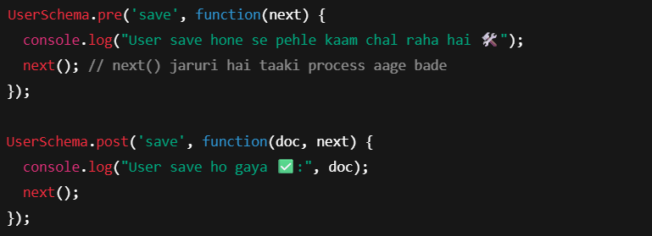

**🛠 3. Full Example Code (ES6 Style)**

import mongoose from "mongoose";

// Step 1: Schema banao

const UserSchema = new mongoose.Schema({

name: String,

email: String,

role: String

});

// Step 2: Pre Hook (before saving document)

UserSchema.pre("save", function(next) {

console.log("🚀 Pre Hook: User save hone se pehle ye chalega");

// Example: name ko uppercase karna

this.name = this.name.toUpperCase();

next();

});

// Step 3: Post Hook (after saving document)

UserSchema.post("save", function(doc, next) {

console.log("✅ Post Hook: User save ho gaya. Data:", doc);

next();

});

// Step 4: Model

const User = mongoose.model("User", UserSchema);

export default User;

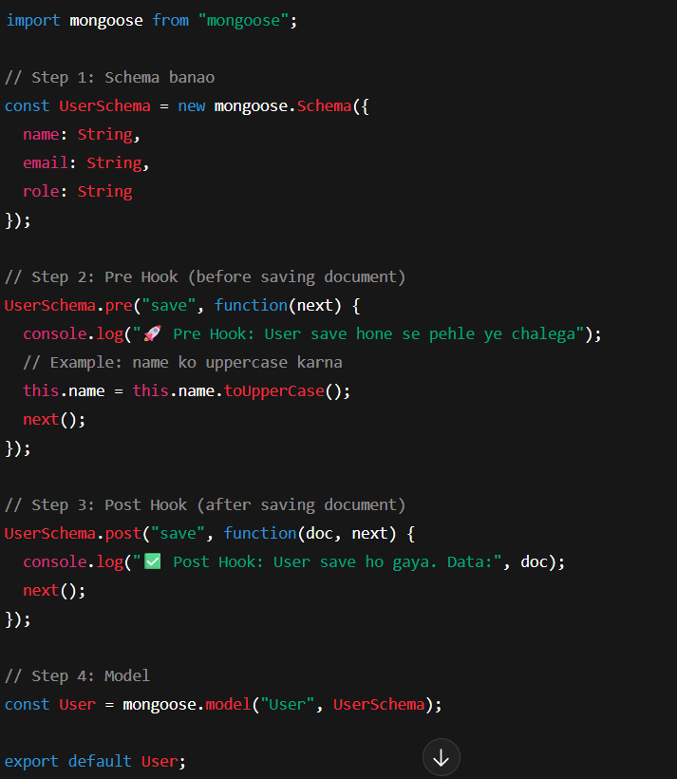

**🛠 4. Exercise**

👉 Postman se ek user create karo:

**POST** http://localhost:5000/users

{

"name": "Rahul Sharma",

"email": "rahul@example.com",

"role": "Frontend Developer"

}

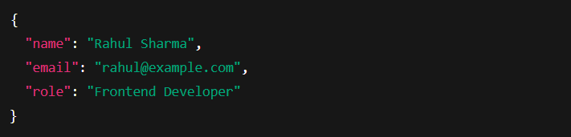

**Output Terminal me:**

🚀 Pre Hook: User save hone se pehle ye chalega

✅ Post Hook: User save ho gaya. Data: { _id: 123, name: "RAHUL SHARMA", email: "rahul@example.com", role: "Frontend Developer" }

**🎯 Desi Summary**

* **Pre Hook** = Kaam hone se pehle automatically trigger (jaise order dene se pehle "Hello Sir!" bolna).
* **Post Hook** = Kaam hone ke baad trigger (jaise khaana khane ke baad "Thank you Sir!" bolna).
* Isse tum **data ko modify kar sakte ho, logs rakh sakte ho, ya extra kaam kara sakte ho** bina har route me likhe.